# Written Resolution of Kirklees College Corporation

**Passed on 16 September 2024**

**In accordance with clause 15 of the Corporation’s Instrument of Government, the following resolution was duly passed by way of written resolution:**

1. To appoint Professor Peter Roberts to the Kirklees College Corporation as an Independent Governor and member of the Kirklees College Finance & Resources Committee.
2. To appoint Sophie Johnson to the Kirklees College Corporation as an Independent Governor and member of the Kirklees College Safeguarding Committee for a term of four years.
3. To appoint Brendan Brown to the Kirklees College Curriculum Strategy Committee as a Co-optee in the first instance and to the Corporation as an Independent Governor when a seat becomes available.
4. To appoint Andrew Fell to the Kirklees College Audit Committee as a Co-optee.
5. To appoint Marcus Smith-Connor to the Kirklees College Curriculum Strategy Committee as a Co-optee.

Each appointment is for a term of for a term of four years, commencing on the date of the first meeting attended, or the date of any Kirklees College new Governor induction training attended, whichever is the sooner.

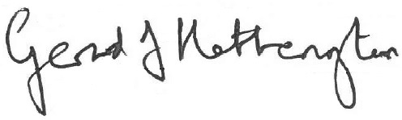

**Signed by Chair**

**Date: 16 September 2024**