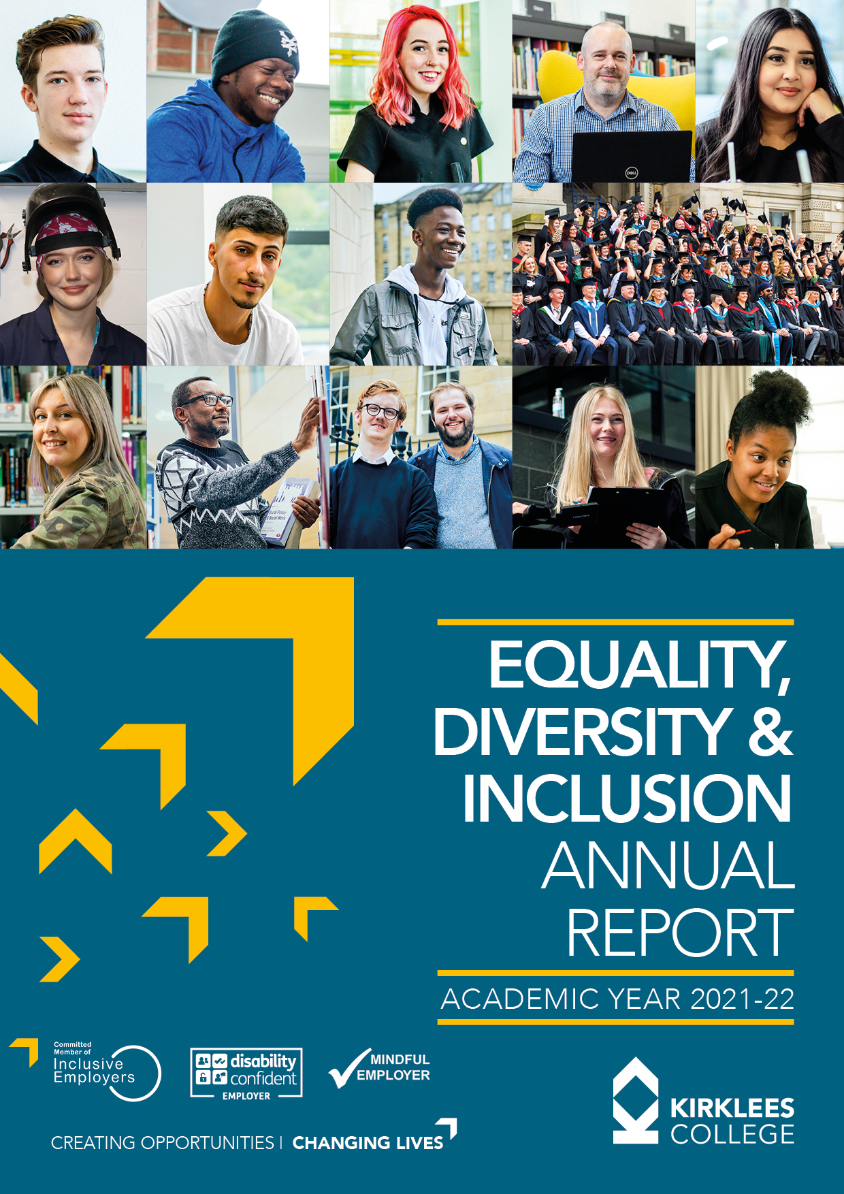

Chris Carson

[Company name]  [Company address]

**Contents Page**

Creating Opportunities, Changing Lives 3

Our Commitment to Equality, Diversity and Inclusion 4

Part 1: Summary and Statutory Obligations 6

Part 2: Equality, diversity and inclusion in teaching,  
learning and assessment 13

Part 3: Analysis of Learner Quality Data 2021/22 23

**Creating Opportunities, Changing Lives**

Kirklees College is a diverse and inclusive organisation which seeks to raise standards of education and training, support the skills needs of employers and act as a positive force for equality of opportunity within Kirklees. We respect our students and colleagues as individuals and celebrate diversity in the rich mix of backgrounds and experiences they bring to the college.

To achieve this, the college is fully committed to treating all students and staff with the respect that they deserve as a unique human being, and to maximising their potential through the power of high quality education and training.

This report takes stock of our position at the end of 2020/21 against our policy objectives and sets out our improvement priorities going forward in 2021/22.

We are often reminded of inequalities that exist in the wider community and we want to use these case studies and events to reflect and change our internal practices.

We will continue to be informed by actions both locally in Kirklees and nationally across the FE sector and use our sphere of influence wherever we believe we can do things to tackle inequalities. We seek to lead industry and local practice and will drive change through our commitment to groups such as the Black FE Leadership Group.

Our mission, “Creating Opportunity, Changing Lives” continues to provide us with focus and we are dedicated to ensuring that we have a college where all students can achieve their potential and where every member of staff can work in an environment where ability and commitment will flourish.



**Palvinder Singh**

**Principal and Chief Executive**

**Our Commitment to Equality, Diversity and Inclusion**

Equality, diversity and inclusion remain core values of Kirklees College as articulated in our mission, values and strategic objectives. Our vision is to sustain a stimulating and supportive environment for all students and staff, distinguished by a commitment to high standards and respect for the individual.

Our commitment to equality, diversity and inclusion remains a business priority. Through engaging, motivating and valuing our employees and students, we strive to maintain organisational success during difficult periods. Kirklees College wholeheartedly supports the principles of equality, diversity and inclusion (EDI) and opposes all forms of unlawful or unfair discrimination on any grounds.

We are committed to recognising and actively promoting EDI within our community. We aim to provide a working and learning environment that acknowledges the richness of diversity and recognises the positive contributions of people of different social backgrounds, cultures, religions, abilities, ages and sexual orientation. Kirklees College seeks to ensure equality of opportunity and treatment for everyone in relation to all of its activities, such as the recruitment and employment of staff, consultants and contractors, the provision of educational opportunities and the provision of training and other services to individuals.

The college will work actively towards eliminating discrimination, harassment, bullying and any other conduct prohibited by the Equality Act. The college recognises the existence of institutionalised discrimination, including institutional racism and is committed to making changes in any area of college practice where there is evidence of failure to provide an appropriate and professional service. It is committed to closing equality gaps in relation to student outcomes and employment issues. We are committed to the Public Sector Equality Duty and the broad range of issues connected with the college’s mission – ‘creating opportunities, changing lives’ – to lead our community through excellence in providing learning and pathways for progression.

The Duty covers equality issues both in employment and in-service delivery. We will:

• comply with the law in promoting equality and where appropriate go beyond the legal requirements

• ensure that all students succeed and can progress in ways that match their abilities and aspirations

• be an organisation that embraces and recognises the talents of all and does not tolerate any form of discrimination or harassment.

We will judge our success by:

• our progress in improving participation, retention and achievement in areas where there is currently inequality

• our ability to maintain the progress of all students

• evidence of all staff adopting a positive approach to equality, diversity and inclusion and their success in doing so

• our progress towards embedding equality, diversity and inclusion within the curriculum

• the completion of the action plan relating to equality, diversity and inclusion

• gaining feedback from students, staff and stakeholders

• our progress in recruiting a diverse workforce and the demonstration of best practice in relation to employment

This report details the work undertaken by the college during 2022/23 and also provides the results of equality and diversity monitoring undertaken during this period.

This report is divided into four parts:

**Part 1** gives a summary of our overall approach and outlines our statutory obligations.

**Part 2** outlines our key achievements and activities which we have undertaken in the past year to advance equality, prevent discrimination and make progress in relation to our Equality Action Plan.

**Part 3** details our focus for 2022/23, specifically a number of national initiatives that the college has signed up for.

**Part 4** details our student equality data. This data is compared with internal historical data and benchmarked where possible with external data. An analysis of this data is produced and used to inform change. *

*\*Please note that the data produced is correct at the time of publication*

**Part 1: Summary and Statutory Obligations**

CREATING OPPORTUNITIES, CHANGING LIVES

The mission celebrates the fact that the college is an institution which embraces the needs of all our community, irrespective of academic achievement and social background, and changes lives through providing a ladder of opportunity and progression through creative, responsive and successful learning.

The college makes a significant difference to improving the lives of those who are most disadvantaged and at risk of long-term unemployment and cross-generational poverty because of poor educational outcomes. Although the Kirklees district has areas of relative affluence, it also has areas of significant deprivation.

The Covid-19 pandemic has continued to have an impact on the education sector and substantial disruption to learning. Our students have faced the challenge of not experiencing formal examinations, inflated grades, compounded by education reforms where there are more exam-based qualifications at Level 3.

Using Indices of Multiple Deprivation, we have a much higher than average number of students who come to us from the three bands of highest deprivation. In addition, many of our students have significantly lower than average starting points in English and maths.

Kirklees College is the key provider of post-16 SEND provision in Kirklees and there have been year-on-year increases in the number of students with EHCPs attending the college in the last three years. This trend looks likely to continue.

With increased focus on equality and diversity in all sectors and in all areas of everyday life, we need to demonstrate and communicate to our stakeholders, both internal and external, that we are committed to providing a supportive, inclusive and respectful environment.

**Our Vision**

Our vision is to be a college at the heart of its community providing inspirational teaching and ensuring curriculum is developed with employers, enabling all students to progress.

We are building a college community that through its leadership, recruitment, teaching and learning is free from discrimination and secure and confident in its diversity. The college is committed to ensuring that every individual student and employee is valued, supported and respected.

We welcome and celebrate the unique talent and experience of each individual student and employee. Effective teaching and learning require a safe environment, free from prejudice and discrimination, where the values and ethos of equality and diversity inform all college activity.

Therefore, Kirklees College has zero tolerance of approach to discrimination. These values apply equally to staff and governors, as well as students, volunteers and organisations that we do business with.

Our Single Equality Scheme and associated policies outline how we seek to ensure that the college is free from unlawful discrimination and strives constantly to move beyond legal compliance towards excellence and best practice in promoting and celebrating equality and diversity.

Through creative and responsive teaching and learning and a broad spectrum of extra-curricular activities, our students will understand better the world within which they live and the impact of their own actions on community cohesion and wellbeing.

**Our Values**

Kirklees College welcomes all students who want to learn. The college has a common set of key values for both students and staff that are at the heart of everything we do. The values define who we are, how we behave and how we interact with each other, making Kirklees College a vibrant, inclusive, educational experience. Our values are:

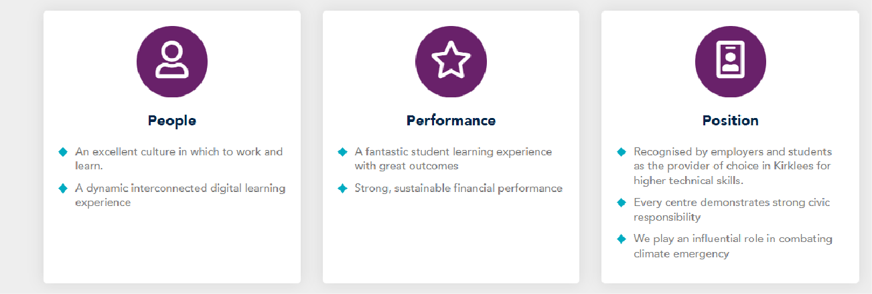

**OUR STRATEGIC GOALS**

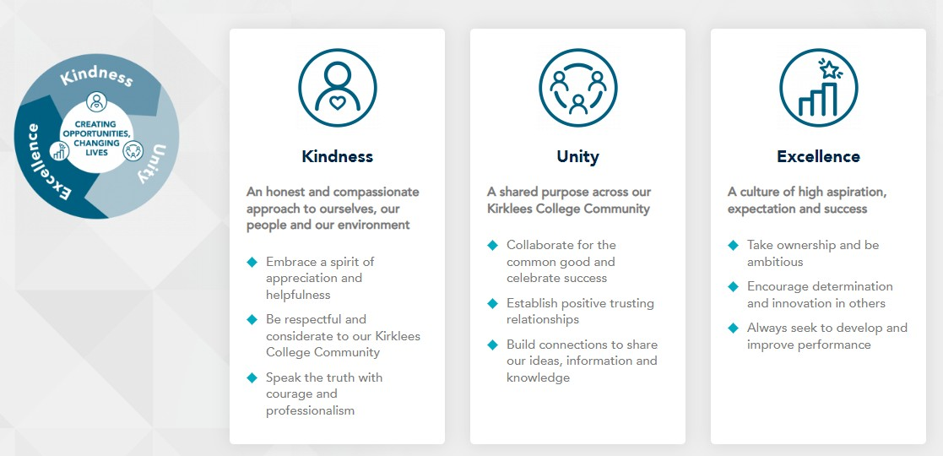

1. **Statutory Reporting Obligations**

The General Equality Duty:

This is set out in section 149 of the Equality Act and requires relevant public authorities to have due regard to the need to:

• eliminate discrimination, harassment, victimisation and any other conduct that is prohibited by or under the Act

• advance equality of opportunity between persons who share a relevant protected characteristic and persons who do not share it

• foster good relations between persons who share a relevant protected characteristic and persons who do not share it

Our Statutory Reporting Obligations arise under the Equality Act 2010 (Specific Duties) Regulations 2011 and require the college to publish:

• specific and measurable equality objectives, at least every four years

• Information to demonstrate its compliance with the public sector equality duty by 31 January each year. We are committed to being open and transparent about the information on which we base our decisions, what we are seeking to achieve and our results. This includes clearly setting out the equality outcomes we are working towards.

1. **Single Equality Scheme (SES)**

The Single Equality Scheme (SES) is linked to the overall college strategic plan and should be read in conjunction with this. The SES should also be read in conjunction with the college Equality and Diversity Policy which is based on legislative compliance and best practice. Finally, the commitments and the detail within this plan have been translated into clearly defined actions as included in the SES Action Plan.

This Single Equality Scheme brings together our commitments to equality, diversity and inclusiveness and our equality ambitions and plans across the organisation. It embraces all members of our college community and its objectives demonstrate our wholehearted commitment to continued action in tackling inequality and promoting diversity and inclusiveness. The scheme and action plan will build on our previous equality work.

We will continue with our efforts to break down barriers and challenge unfairness, ensuring we provide opportunities and experiences which help people and communities reach their full potential.

The scheme also sets out our intentions to:

• make equality a reality for people accessing our services, seeking job opportunities and who are currently employed with the college

• fulfil our legal responsibilities

• inform people of our responsibilities and how we will fulfil them

• show how our scheme links to our broader equalities’ objectives and priorities

• provide information about our consultation and engagement, monitoring and training arrangements

1. **Equality Impact Assessment**

Equality Impact Assessment’s (EIA’s) are a tool to help organisations, such as our college, assess the likely impact of policies, procedures and services on different groups of people. There is no legal requirement to carry out EIA’s, however, we want to carry them out as they fit our college values including our commitment to equality, diversity and inclusion. This year we have embedded our refreshed EIA process which has enabled us to challenge ourselves to ensure that EDI is an integral part of the work we do and that our processes and practices are robust.

EIA’s will be carried out on:

• new functions, policies, procedures and services as they are developed

• significantly altered functions, policies, procedures and services

• existing functions and policies over a period of time

The EIA process considers all nine protected characteristics or strands of equality – age, disability, gender reassignment, marriage and civil partnership, pregnancy and maternity, race, religion or belief, sex, sexual orientation

1. **Access to Services and Information**

One of the college’s priorities is that our services are fully accessible to all parts of the community. Our programme of analysis and assessment of any potential impact should highlight any factors which indirectly discriminate by making a particular service less accessible to particular groups. We are committed to acting to address any barriers experienced by any section of our community.

We recognise the importance of not only communicating our clear commitment to equality, diversity and inclusion but also the importance of keeping stakeholders regularly informed of the progress being made and the outcomes being achieved. This includes opportunities for the community to take part in this work and help contribute to the improvements that the college is seeking. Our aim is to publish information in the most customer friendly, accessible, practical and cost-effective way and we communicate our messages by:

• letter

• the media

• at specifically arranged meetings with particular groups and individuals

• email

• telephone, using an interpreter if needed

• summary reports

• using appropriate and accessible multimedia

1. **Employment Monitoring**

We collect information about the profile of our corporation members and the workforce relating to age, disability, gender reassignment, race, sex, and sexual orientation to include in our workforce profile analysis. Our employment monitoring includes an analysis of starters and leavers, absence, grievance, disciplinary and underperformance.

We also report on the profile of job applicants and their success rates. More specifically, our employment monitoring covers the numbers of:

• employees in post

• applicants for employment with conversion rates

• employees involved in grievance procedures

• employees the subject of underperformance

• employees the subject of disciplinary and absence management procedures

• employees that cease employment with the college

The data is used to identify any differential impact of the college’s employment and recruitment practices on people from different groups, such as ethnic background. The college takes steps to address any adverse findings as a result of this analysis. Once collated, the information is made publicly available via the college’s website and the annual report. We will analyse and publish this annual report on our website, which includes the full set of employment monitoring information on an annual basis, as required by the Equality Act 2010.

1. **Promotion and Communication of Equality, Diversity and Inclusion**

Our statement on equality, diversity and inclusion identifies what staff need to do and who can help if they experience or witness any form of bullying or harassment against themselves or others. This is visible in and around college to all staff members. The Human Resources and EDI sections of the intranet include information and resources on all areas of diversity, analysis and assessment of the impact of our services, updates on legislation, community information and news updates. Equality, diversity and inclusion is promoted to staff, students and governors at induction to ensure that the college values and behaviours are well understood.

There are a range of resources and materials available online to support teachers and assessors. Teachers and trainers explore opportunities to further develop understanding of equality, diversity and inclusion and it is integral to the tutorial framework. The college communication strategy has a focus on equality, diversity and inclusion to ensure all staff are aware of their responsibilities. The executive and senior management team are invested in embedding this into all areas of the college and to increasing stakeholder commitment and awareness.

1. **Leadership and Management**

**The corporation is responsible for:**

• for approving and upholding the college values, including inclusivity, diversity and belonging

• ensuring that the college complies with its legislative duties, including the general and specific duties

• ensuring that adequate strategies and systems are in place

**The Principal and Senior Leadership Team are responsible for:**

• providing a consistent and inclusive leadership that assures all team members that they will be treated respectfully and fairly, are valued, have a sense of belonging and are confident and inspired

• providing a high-profile lead to chair the Equality, Diversity and Inclusion Strategic Group, ensuring that equality is covered as an agenda item at each cross-college meeting

• promoting a general awareness of equality within and outside college

• requiring managerial action to implement the duty and related policies

• ensuring the Equality Duty and its aims are followed

**Managers are responsible for:**

• providing a consistent and inclusive management style that assures all team members that they will be treated respectfully and fairly, are valued, have a sense of belonging and are confident and inspired

• implementing the duty and its related aims and strategies

• ensuring that all staff are aware of their responsibilities and are given appropriate training and support

• following the relevant procedures in taking appropriate action against staff or learners who carry out unlawful discrimination

**All staff are responsible for:**

• ensuring they are aware of the college’s statutory duties in relation to equality legislation

• eliminating unlawful discrimination, harassment, victimisation and any other conduct prohibited by the Equality Act 2010

• promoting positive attitudes towards equality, diversity and inclusion

• attending staff development and information opportunities in order to keep up to date with legislation and college requirements regarding equality, diversity and inclusion

**Contractors and service providers are responsible for:**

• complying with the equality requirements set out in the contract or agreement (the college is responsible for ensuring the requirements of the positive duty are met in those functions delivered under contract)

• Contracts and agreements should include a requirement to comply with the college’s Equality and Diversity policy

**The Equality, Diversity and Inclusion Strategic Group is responsible for supporting the Senior Leadership team in:**

• ensuring that all students and staff are enabled to achieve their full potential, irrespective of a protective characteristic

• ensuring that Kirklees College is seen as a beacon of best practice within the community

1. **Responsibility when working with other organisations**

The college is responsible for meeting the General Equality Duty when carrying out functions with other organisations. If the partner is another public authority also bound by the duty, each organisation will be responsible for meeting its general duty and any specific duties. If the partners are private or voluntary organisations it will be the responsibility of the college to ensure that the work done jointly meets its Equality Duty.

1. **Consultation with Stakeholders**

The college will endeavour to actively involve people with protected characteristics in policy and decision-making activities. Relevant groups will include:

• current students

• future students

• employees

• local companies

• local voluntary groups

• members of the wider community and individuals who use the services of the college

• Staff EDI Consultant group

We will engage people using a range of methods such as:

• staff and student satisfaction surveys

• focus groups

• existing consultation mechanisms

1. **Monitoring and Evaluation**

The Equality, Diversity and Inclusion Strategic Group will monitor the effectiveness of the Single Equality Scheme and agree actions to be incorporated into the annual Equality Action plan. The Equality Duty will be reviewed and revised every four years. An annual report will be published on the progress made towards meeting the targets set in the action plan. The annual report will be approved by the Corporation prior to being disseminated throughout the college and published on the website.

The annual report will review the college’s progress towards fulfilling its obligations under the Equality Duty, (i.e. the action plan) and meeting its targets. It will include information on consultations with potentially disadvantaged groups and the resulting actions. It will also consider how policies and procedures have been amended in order to eliminate discrimination and promote equality of opportunity

**PART 2: Equality, diversity and inclusion in teaching, learning and assessment**

Kirklees College is proud to be working effectively to further enhance, embed and promote equality, diversity and inclusion through our robust quality and teaching, learning and assessment (TLA) strategies. The college has also strengthened its approach towards the learning and promotion of British Values across the college community and beyond within our local communities. Teachers at Kirklees College create a positive, welcoming and inclusive environment in their classes ensuring there is a culture of respect that results in appropriate behaviour for learning.

*‘97% of students felt the college is a welcoming place for people of all backgrounds’ –* Term 3 Student Experience Survey (1% increase from previous year).

*‘A large majority of students across the college also felt they were treated with respect by everyone’* – 94% in the Term 3 Student Experience Survey, (1% increase from previous year).

The college is on a Journey to Excellence with curriculum teams actively developing their self-identified areas for improvement using the Professional Teaching Standards (PS) under the college SPARC programme. The college SPARC programme includes the ETF self-assessment focusing on EDI in planning and delivery, encouraging further EDI reflection in teacher’s pledges: ‘Value and champion diversity, equality of opportunity inclusion and social equality.’

At the college, we ensure that our teacher training programmes equip our teachers with the tools and skills they need to plan for and deliver an inclusive curriculum. This is explicit in the policy and curriculum module of their programme and trainee teachers research and present various inclusive concepts to assist them in developing inclusive lessons and curriculum schemes of learning.

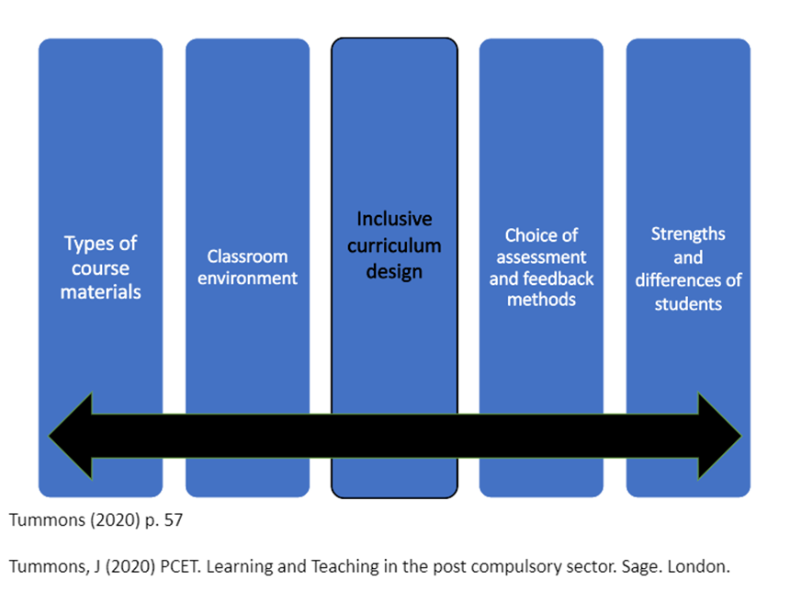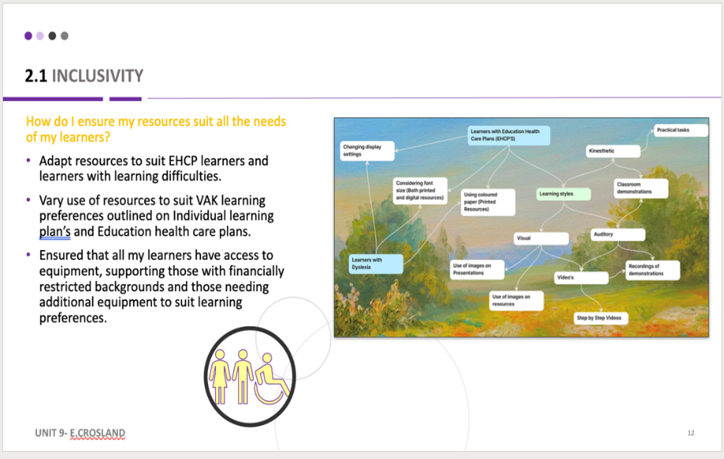

Below is a trainee teacher’s paper who teaches in media makeup, currently working on her subject specialist conference paper for the university conference:

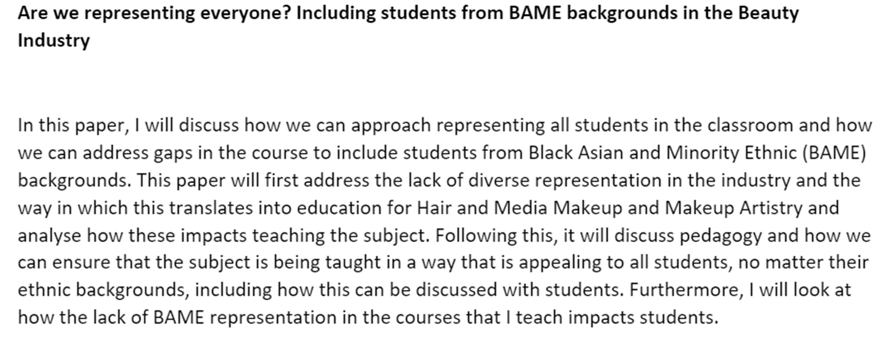

**In year performance data**

Demographic groups currently reported on as part of the college’s system for measuring achievement, retention and pass rate data are Sex, Ethnic Group & Disability/Learning difficulty status.

For 16-18-year-olds, females of a non-white ethnic group have higher retention at 83% than males of a non-white ethnic group (76%), white females (78%) and white males (75%).

For 16-18-year-olds, students of a mixed ethnic background had lower retention at 84% than those of other ethnicities at 87%, though this gap has narrowed slightly since the previous year. Pass rates for students of mixed ethnic background are also 3% lower than those of other ethnicities.

For adults in 20/21, white students had 8% higher pass rates than non-white students. Improved pass rates in ESOL closed this gap to under 1% in 21/22.

In 20/21, male apprentices had 15% lower achievement than female apprentices due to lower achievement in the predominately male area of Construction and Engineering. Improved achievement in these areas has narrowed this gap to 7% in 21/22.

Students in receipt of free school meals have achievement in line with their peers, against a national trend of this group performing below their peers.

Students in vulnerable groups, such as Looked After Children, Care Leavers, Young Carers and Young Parents have pass rates in line with their peers, despite being among the groups to have had the most lost learning time during the pandemic.

**College demography**

The following graphs compare the demography of the college, obtained either from ProSolution or the student survey, with the demography of Kirklees as per the 2021 Census results. Data reporting for the North South division is still being produced.

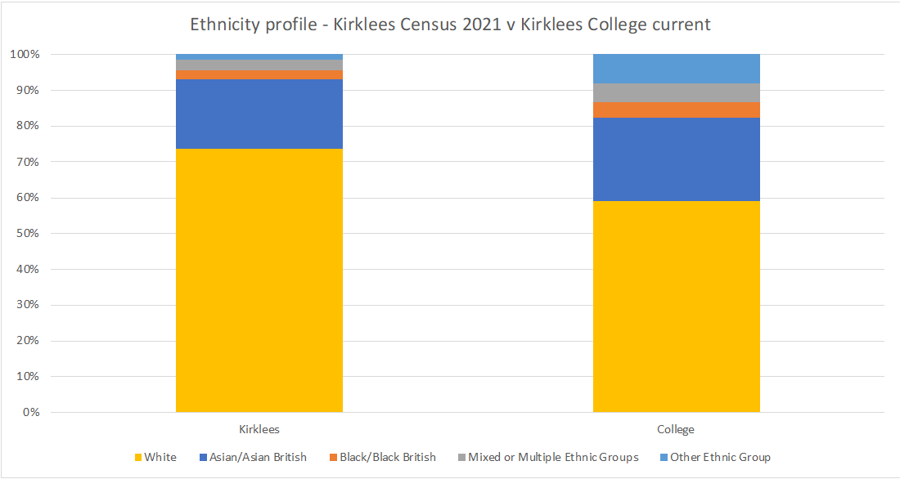

The college has a student population that is more ethnically diverse than the Kirklees region with 41% of students from a non-white ethnic background compared with 26% for the population of Kirklees.

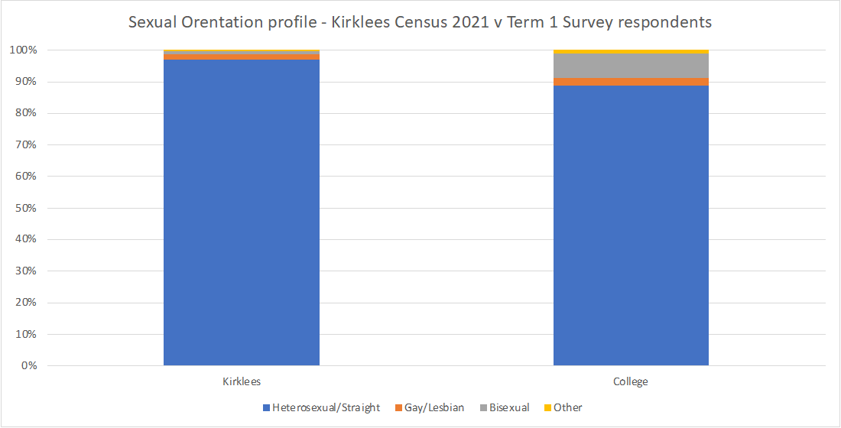

Students at Kirklees College are more likely to identify as a sexuality other than heterosexual, with 11% identifying as another sexuality on the student survey, compared with 3% of people in Kirklees who answered this question on the census.

The college student population is naturally younger than the Kirklees population and other research suggests that younger people are more likely to identify as not being heterosexual. However, the census data currently available doesn’t break this data down by age at a regional level.

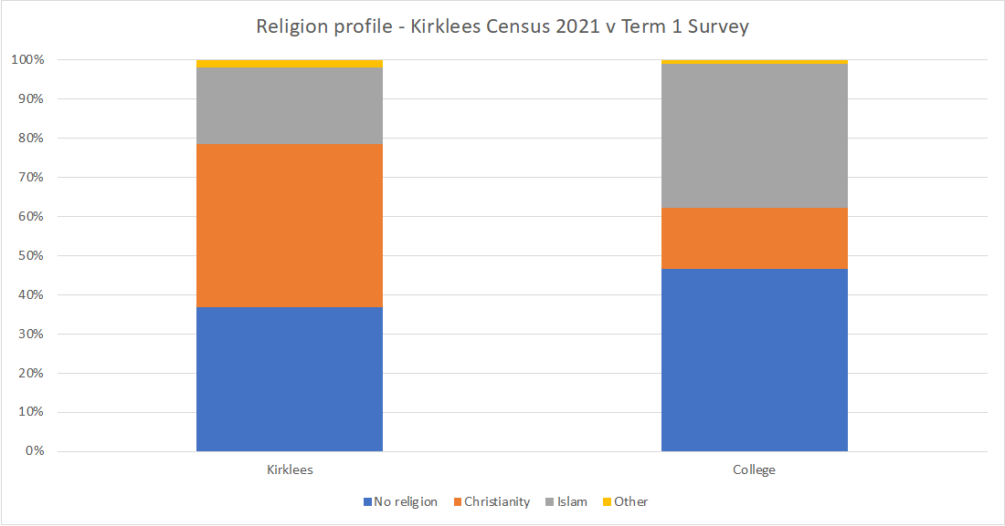

The college’s student population has much more diversity in terms of religious belief than Kirklees as a whole. In Kirklees, 42% of the population said that they were Christian on the census but at college, just 16% of students who answered the question on the survey said that they were Christian.

The proportion saying that they have no religion is higher at college at 47% compared with 37% in Kirklees as a whole. As with sexual orientation, younger people tend to be much more likely to have no religion, with a survey done in 2018 reporting that 70% of people between the ages of 16 - 29 had no religion.

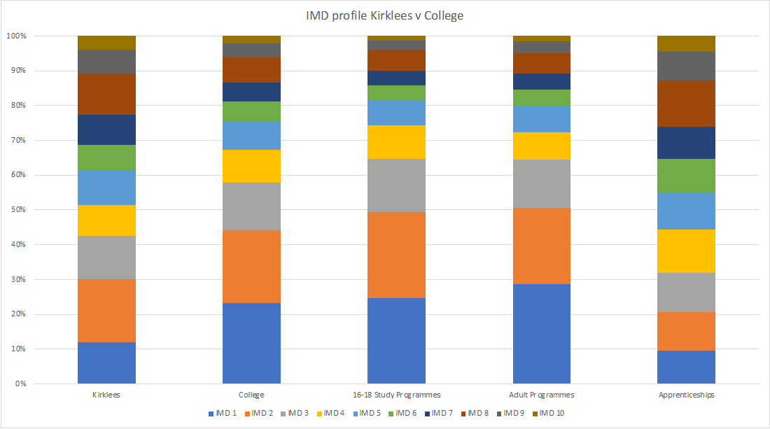

*Note: Kirklees data based on IMD data form 2019, not the census.*

Students on study programmes and adult programmes are much more likely to live in an area in the three bands of highest deprivation (IMD 1-3) than the average Kirklees resident. 65% of study programme students and 64% of students on adult programmes come from these areas, whilst the Kirklees population living in these areas is 42%.

However, for apprentices, only 32% live in these areas.

**Inclusive Curriculum**

The Adult Learning curriculum has been designed to provide our adults with opportunities to transform their lives. The offer aims to provide adults with the chance to gain new or higher skills and knowledge as a vehicle to improve life chances, delivering a range of informal and formal learning from pre-entry-level courses to professional/ technical qualifications and Access to Higher Education, as well as confidence-boosting/wellbeing programmes and family learning. The Adult curriculum is aligned to several inter-related national and regional policies and priorities

The curriculum is diverse, developing students’ resilience and wellbeing. Art for relaxation, chair yoga, family art and wellbeing, painting for a positive mind and wellbeing walks have provided residents with opportunities to focus on their mental health and wellbeing.

Courses are helping individuals to have more control of their own lives, such as being able to attend medical appointments, participate in official engagements, such as the Home Office or solicitors by themselves or speak to their child’s teacher or assist with their homework. The impact is that they are able to be more independent and gain skills to flourish in society.

Students have enhanced their confidence as they have improved their spoken English through class presentations or group discussions and have enhanced knowledge of grammar to write correct sentences since starting the course. The impact is that students appreciate and are positive about the benefits of programmes and how they have improved their knowledge which can be applied in personal and social contexts and improve their employability skills.

The impact of the taught curriculum is good. Students develop high quality skills enabling them to make positive contributions in their workplace and their community. Achievement on community learning programmes is 95% and those completing awards and certificates is 94%. This has remained consistently high for more than four years.

95.75% of adult students agree that their course has encouraged them to be an independent student.

Adult achievement is now 88%, which is a 4% improvement from 2020-2021 and a 1% improvement from 2019-2020. ESOL achievement rates have improved by 9% from 2020-2021.

ESOL retention has remained high at 92% and in line with previous years, which has resulted in adults achieving and progressing into the world of work and higher-level qualifications.

The apprenticeship curriculum has been designed to provide young people and adults with the opportunity to gain hands-on work experience with the opportunity to train and obtain qualifications. The offer aims to provide students with the chance to gain new or higher skills and knowledge as a vehicle to improve life chances.

The apprenticeship curriculum aims to be flexible, accessible and responsive to the existing and future needs of a wide range of employers and students across the West Yorkshire footprint. There are exemplary partnerships with employers which ensures the curriculum intent is aligned to local and regional economic needs and allows students to access learning opportunities.

Improved achievement in Engineering and Construction has helped narrow the achievement gap between male apprentices and female apprentices from 15% to 7%.

High needs students enrol on programmes within every department and level within the college, including vocational courses and specialist provision (Foundation Learning). Inclusion plans are developed for every high need student, identifying the provision that they require and how these can be met through QTF, assistive technologies and specialist support to ensure they achieve their outcomes.

Kirklees College promotes inclusive learning environments and encourages staff to employ Quality First Teaching (QFT) strategies and a range of assessment methods for the benefit of all students, not just those with learning disabilities/difficulties. Refresher training has been delivered to all curriculum teams to understand the provisions and effectively use strategies to support students to meet their outcomes. The college has a comprehensive support team that covers all areas of the college providing support and guidance to curriculum teams. Where required, the college provides specialist support or assistive technologies in addition to QFT strategies through its graduated approach. The aim is to gradually withdrawal support where appropriate to develop independence, autonomy and work readiness.

Additional learning support may be provided in class in small groups or on a 1:1 basis to support students to develop their own strategies to enhance their skills, knowledge and behaviours for greater independence. As students develop these skills, in class support is reduced but students are still able to access out of class support in the Oasis rooms that are staffed by the SEND Support team.

The Motor Vehicle provision in Springfield Sixth Form Centre has been aligned to the Foundation Learning department to improve outcomes and provide more effective support for these students. The Tuition Fund is effectively utilised to provide high needs students that are enrolled on a maths or English qualification with additional tutoring in small group or 1:1 setting in maths and/or English. The Century Tec Learning Platform has been introduced this academic year for both maths and English and is encouraged with all high need’s students. After the diagnostic assessment is taken in September, Century creates individual pathways so that students can work on their individual targets. This is monitored by staff and regular intervals are set in the year for students to look at their progress and update SMART targets.

High needs students within vocational areas participate in work experience and employability activities in line with their peers. Curriculum teams, work placement officers and the SEND Support team work collaboratively to ensure that reasonable adjustments are in place to enable students to participate in meaningful experiences. For students on the Training and Employment pathway in Foundation Learning, employability and work-related activities, such as placements in realistic working environments and in the wider community, are undertaken to develop students’ knowledge, skills and behaviour to prepare them for the workplace.

The approach for Pre-supported Internship differs in design to provide more opportunities for students to be independent and resilient by taking part in group placements outside of the college. The Supported Internship Programme is planned to provide job rotations that are matched to the student’s individual career aspirations. Interns receive high quality, ongoing support from job coaches and opportunities to understand how to keep themselves safe and healthy from the curriculum lead. The strength of this partnership has resulted in outstanding employment rates for the first cohort with Kirklees Council and the programme has been recognised nationally as an example of good practice with DFN Project Search.

Students are also able to access high quality, impartial careers guidance that enables students to develop clear and ambitious but realistic plans for the future. These plans are used by curriculum teams to develop personalised targets and form the basis of discussions during termly SEND reviews and annual EHCP reviews. High needs students in specialist provision participate in work in the community and employers using real briefs for clients on the Work Skills programme. The Work Focus Café staff link with the catering services and Health and Safety team to ensure that they are equipping students with industry standard knowledge, such as barista skills, food labelling and hygiene standards.

• Retention (90.14%), achievement (83.88%) and pass rates (93.05%) for high needs students are above whole college and last published national rates for LDD students in FE

• Students demonstrate good behaviours and attend well

• High quality learning environments enable students to develop skills and knowledge whilst providing appropriate spaces for regulation and reflection

• Students have opportunities to participate in a wide range of activities that enable them to become more active citizens and members of their community

• Outstanding positive destinations at 97.71% for young people; 100% meaningful employment for first cohort of Supported Interns with Kirklees Council well above national benchmark (70%)

• Students benefit from excellent opportunities to participate in work experience

**Case Studies**

Daniel has moderate hearing loss. He has been at college for three years studying Art and Design. He has developed independence to manage his learning with minimal support, allowing him to progress to higher education in September 2023.

Dylan has been at college for five years starting on Work Skills in Foundation Learning. He has made good progress but had a change of direction in 2019. He moved from Public Services to Hospitality and Catering, progressing to a Level 3 Diploma in Professional Cookery in 2022/23. He has secured part-time employment in this sector alongside his studies.

Macaulay made rapid progress whilst on his Supported Internship and secured employment in year with First Bus, thus realising his dream of becoming a bus driver with the help and support of the team.

Emma began her studies at Kirklees College on Entry Level 2 at our Springfield Sixth Form Centre and has progressed through and out of the department to Project Search this year. She has explored her joy of Art and Design whilst developing her academic and personal skills. Her long-term aspiration is within Hospitality and Catering, and she has completed two rotations to date with the NHS within these departments.

*Further examples of where we have seen inclusivity within the classroom:*

The Health and Social Care delivery team use the ‘Kirk family’ in their assignment briefs. The family has been created to cover a wide range of cultural backgrounds, disabilities and how these in turn are supported by diverse multi-agency teams.

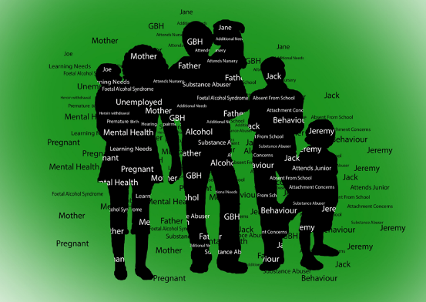

Recently through our learning walks within curriculum, it was noted that a Plumbing Level 1 group were observed discussing water sources and supplies in different countries, particularly third world countries and healthy diverse debate followed.

During similar learning walk activities, a Media Makeup group was observed exploring different ethnicities and skin types for application of makeup. These were being explored to promote wider knowledge and understanding of potential client base with the students.

**Kirklees College EDI Case Studies**

**Women in Construction Event**

On Wednesday 8 February, we hosted our Women in Construction Event at our Brunel Construction Centre. Students from local schools attended and participates in a range of activities, including presentations, employer workshops, tours and hands-on demonstrations.

Employers in attendance included [Willmott Dixon](https://www.willmottdixon.co.uk/), [Gleeson Homes](https://gleesonhomes.co.uk/), [Little Miss Electrical](https://littlemisselectrical.co.uk/), [Kirklees Council](https://www.kirklees.gov.uk/beta/default.aspx), [Tilbury Douglas](https://tilburydouglas.co.uk/) and [VINCI](https://www.vinciconstruction.co.uk/).

The employers gave talks to the students about apprenticeship and career opportunities, encouraging more women to get into the Construction sector.

Steve Plumstead, Head of Faculty for Construction and Land-Based Studies said about the event: “It was great to see so many local students and employers attend our Women in Construction event. We hope the event inspired a new generation of young women to get into Construction, an industry with fantastic opportunities for everyone.”

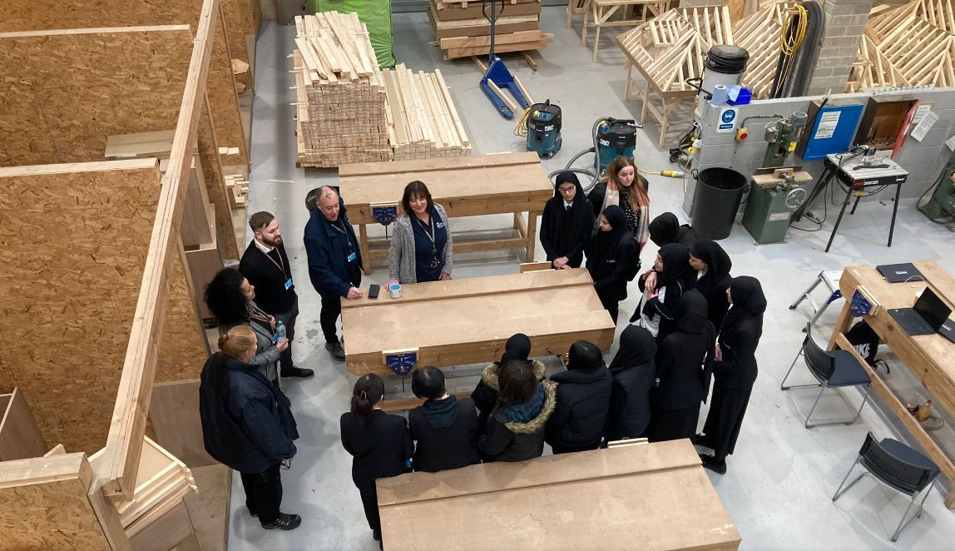

**Partnership with Yorkshire Asian Business Association**

Kirklees College are delighted to announce our renewed corporate partnership with Yorkshire Asian Business Association (YABA).

The partnership allows our two organisations to support and promote one another and will also see staff members from YABA working from the college as part of the partnership.

The staff members already work for YABA and will continue their training and employment with the organisation from the 6th floor of our Huddersfield Centre. They will be working here to drive apprenticeship opportunities, and we look forward to welcoming them to the KC Community.

Representatives from YABA and Kirklees College were joined by the Mayor of Kirklees, Councillor Masood Ahmed, for a meeting to celebrate the partnership on Monday 30 January.

The Mayor said:

“Having attended and worked at Kirklees College, it is always a pleasure to return to see how it has developed over the years. The partnership with the Yorkshire Asian Business Association will hopefully see both organisations flourish and enhance the education and employment opportunities for young people in our borough.”

Palvinder Singh, Principal and CEO for Kirklees College remarked:

“This new stage of our partnership marks the beginning of a new venture for both YABA and the college. Working with YABA allows us to expand our opportunities for young people in a way that reflects the diversity of Kirklees.”

“We look forward to welcoming YABA to the KC community and by having them work in our offices, we will be able to support YABA’s corporate, business and community ventures”.

Sharon Jandhu OBE from YABA commented:

“It was excellent to meet with the Lord Mayor of Kirklees Cllr Masood Ahmed, Palvinder Singh and the team at Kirklees College to discuss and launch the new and exciting partnership YABA has with Kirklees College, with a shared purpose of improving the lives and opportunities for young people in Kirklees and across the Yorkshire region.

It was inspiring to see the hard work that the Kirklees College team have done to help local young people and we cannot wait to work with them to continue to improve the lives of the young people. We look forward to bridging the gaps between companies and the college and seeing this new partnership flourish.”

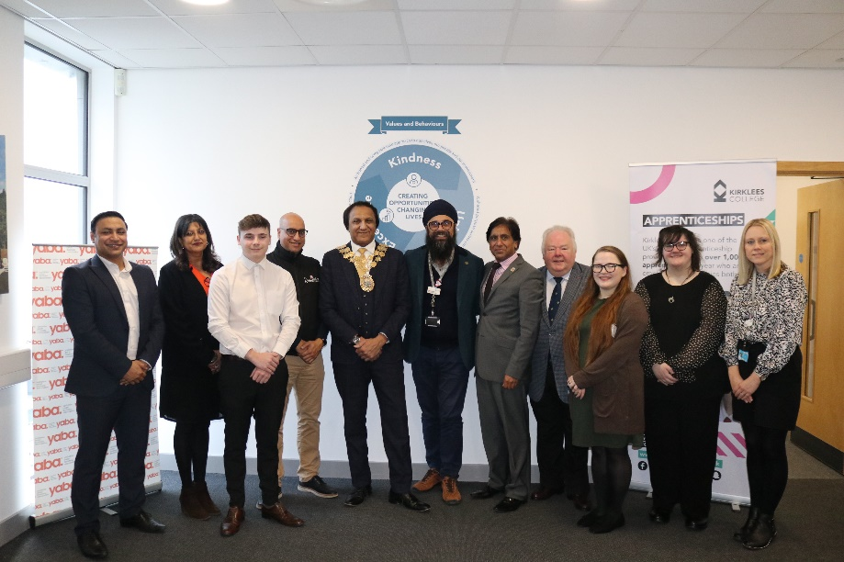

**Project SEARCH Partnership**

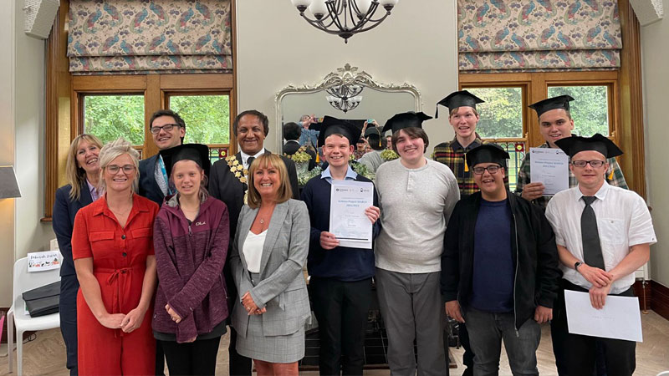

Seven young people with learning disabilities and autism have graduated from the DFN Project SEARCH programme run in partnership with Kirklees College and Kirklees Council.

Project SEARCH provides young people with a learning disability and/or autism the opportunity to gain the skills needed in a real work environment and achieve paid employment. Project Search finds young people aged 18-24, in their last year of education, whose talents may be overlooked in the job market, and matches their skills to roles within a business.

The graduates received their certificates in front of their family and rotation managers. Three interns also stood up to address the room and give speeches about their time with Project SEARCH.

Following the programme, Kirklees Council project that over 75 per cent of the first cohort of interns will successfully transition into sustained employment, with four out of the seven interns already securing paid employment.

Polly Harrow, Assistant Principal for Student Experience at Kirklees College said:

“I am so proud of the incredible partnership we have with Project SEARCH, who help us to provide a phenomenal programme for our brilliant students at Kirklees College. The team at Project SEARCH allow us to make such a difference to the lives of the students who really deserve it. Our students are graduating with confidence, support and transferable skills which will help them make the most out of their future. Well done to all the students and staff involved with Project SEARCH.”

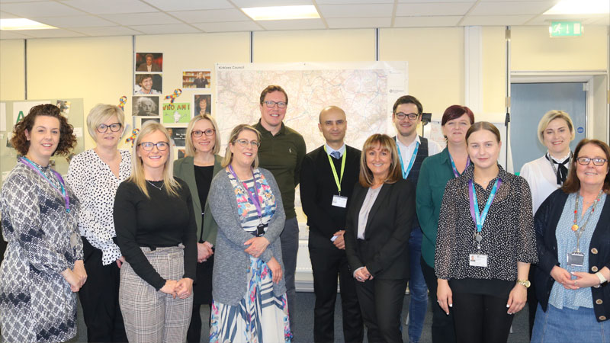

On Friday 11 March, Kirklees Project SEARCH Huddersfield had a visit from DFN Project SEARCH’s CEO, Claire Cookson, along with Programme Specialist Sarah Palmer, the Kirklees Council Senior Leadership Team, Kirklees College Senior Leadership Team, REAL Employment and Matt Boyle, Marketing Director of Witherslack Group.

Kirklees College is currently working alongside Kirklees Council, providing a series of rotations (work placements) for interns to gain valuable work experience and the transferrable skills needed for the working world.

The main purpose of the visit was to showcase good practice at the Huddersfield site. The visit also gave Matt an insight into the fantastic work of Project SEARCH as a potential progression pathway for some of Witherslack Group’s students.

They went out to observe two interns in their rotations and asked them lots of questions about their aspirations and goals. The visit was a great success and an excellent opportunity for the host business and Project SEARCH to meet.

Claire Cookson, CEO of Project SEARCH said:

“We have an incredible partnership with Kirklees College. The drive, determination and values you all share to provide a phenomenal programme is something very special indeed. You are a shining light of just what can be achieved using the DFN Project SEARCH model. I was blown away. Thank you for being a showcase site. The visit was such a wonderful reminder of why we all do what we do, and how together we can make a huge difference to the lives of people who really deserve it. Thank you, brilliant Team Kirklees.”

**PART 3: Analysis of Learner Quality Data 2021/22**

1. **Analysis of Student Equality Data 2021/22**

For 16-18-year-olds, females of a non-white ethnic group have higher retention at 83% than males of a non-white ethnic group (76%), white females (78%) and white males (75%).

For 16-18-year-olds, students of a mixed ethnic background had lower retention at 84% than those of other ethnicities at 87%, though this gap has narrowed slightly since the previous year. Pass rates for students of mixed ethnic background are also 3% lower than those of other ethnicities.

For adults in 20-21, white students had 8% higher pass rates than non-white students. Improved pass rates in ESOL closed this gap to under 1% in 21-22.

In 20-21, male apprentices had 15% lower achievement than female apprentices due to lower achievement in the predominately male area of Construction and Engineering. Improved achievement in these areas has narrowed this gap to 7% in 21-22.

Students in receipt of free school meals have achievement in line with their peers, against a national trend of this group performing below their peers.

Students in vulnerable groups such as Looked After Children, Care Leavers, Young Carers and Young Parents have pass rates in line with their peers, despite being among the groups to have had the most lost learning time during the pandemic.

Achievement was much higher in 19-20 and 20-21 due to calculated grades during the pandemic.

**Table: Achievement and Retention by Ethnic Group 2019/20 to 2021/22**



1. **Support for Learners with Learning Difficulties and Disabilities**

Learning Support is available to all students that declare that they have a need, a disability, learning difficulty or health requirement through the provision of reasonable adjustments. This is delivered through a graduated approach to support, including the use of effective Quality Teach First strategies, general in class and specialist support.

The SEND Support teams provide the following services across college:

* A dedicated team of SENDCOs that provide specialist guidance and support relating to Learning difficulties and disabilities (LDD), Social, Specific Learning difficulties (SpLD), Emotional and Mental Health (SEMH), Autism Spectrum Condition (ASC), Hearing Impairment (HI), Visual Impairment (VI), Medical & Access. Each SENDCO has allocated departments and oversees the provision of support within the area
* SEND Leads coordinate support and facilitate the majority of annual EHCP reviews to ensure that students need are being met to enable them to make academic progress and achieve their EHCP outcomes
* SEND Mentors provide specialist support for dyslexia and dyspraxia in workshop and 1:1 setting
* The Care Team focuses on accessibility and personal assistance, medication, mobility, personal hygiene and assisted transport
* The Student Support Assistants deliver one to one and in class support for learners with a wide range learning difficulties and disabilities at all levels of study and across the whole college curriculum
* The Hearing impairment and Visual impairment teams offer support through communication support workers, assistive technologies, assessments and modifications across all college sites
* Oasis rooms are available at centres for students to work in small group settings and also provides a space for students to regulate and contemplate when required
* The SEND Support team work in collaboration with exams to ensure that exam access arrangements are in place for students to ensure that they have accommodations that match their normal ways of working. These may include reader pens, scribes, readers and alternative environments for the assessments.

The SEND Support team may also arrange:

* + Additional support in elements of the programme, such as maths and English, tutorial, enrichment or work placement
  + Assistive Technologies
  + Specialist equipment
  + Lego Therapy
  + Social stories
  + Speech and Language Therapy (SaLT)
  + Social Use of Language (SULP)
  + Access to Educational Psychology guidance
  + Occupational therapy
  + Physiotherapy

**HIGH NEEDS STUDENTS:**

|  |  |  |  |  |  |  |  |  |
| --- | --- | --- | --- | --- | --- | --- | --- | --- |
|  | **2018/19**  **(889)** | **2019/20**  **(1066)** | **2020/21**  **(1216)** | **2021/22**  **(1196)** | **whole college** | **+/- whole college** | **NR**  **16-18 LDD** | **+/- NR** |
|  |  |  |  |  |  |  |  |  |
| Achievement | 89.28% | 91.99% | 90.65% | 83.95% | 83.46% | 0.49% | 82.00% | 1.95% |
| Retention | 95.37% | 97.33% | 95.09% | 90.22% | 89.73% | 0.49% | 91.00% | -0.78% |
| Pass rates | 93.61% | 94.52% | 95.33% | 93.05% | 93.01% | 0.04% | 90.10% | 2.95% |

|  |  |  |  |  |  |  |  |
| --- | --- | --- | --- | --- | --- | --- | --- |
|  | **2017/18** | **2018/19** | **2019/20** | **2020/21** | **2021/22** | **whole college** | **+/- whole college** |
| Attendance | 89.00% | 89.75 | 87.24% | 87.09% | 85.12% | 80.52% | 4.60% |

Despite a dip in retention compared to the previous year, outcomes for high needs students continue to be good and above whole college for achievement, retention and pass rate and above national rate for learners with LDD.

**High needs**

* Achievement rates higher than national rate (NR) for last three years
* Achievement rates are 83.95 % compared to 82.0% NR, a difference of +1.95%
* Retention continues to be an issue with a drop of 4.87% compared to the previous year. Retention continues to be higher for high needs students than the whole college
* Pass rates are 93.05% compared to 90.10% NR, a difference of +2.95%
* Attendance for High Needs students is good at 85.12%, and 4.60% above the whole college rate

|  |  |  |  |  |  |  |  |  |
| --- | --- | --- | --- | --- | --- | --- | --- | --- |
| **Total Cohort** | **2018/19**  **(986)** | **2019/20**  **(1042)** | **2020/21**  **(799)** | **2021/22**  **(554)** | **whole college** | **+/- whole college** | **NR**  **ALL LDD** | **+/- NR** |
| Achievement | 89.77% | 92.03% | 87.59% | 86.45% | 83.46% | 2.99% | 84.70% | 1.75% |
| Retention | 93.07% | 97.12% | 95.49% | 91.60% | 89.73% | 1.87% | 91.70% | 0.10% |
| Pass rates | 96.46% | 94.76% | 91.73% | 94.38% | 93.01% | 1.37% | 92.40% | 1.98% |

**By ethnic group**

The greatest retention challenge is for students with a mixed ethnicity. There were 68 leavers in 2021/22 and their retention was 83.82%, 6.4% below the overall high needs’ cohort. Other Asian at 81.82% and unknown 50% have lower retention but are very small cohorts with 11 and 4 leavers respectively. Support for students with an unknown ethnicity is good with students achieving their qualifications. All other ethnic groups have achievement rates above those of the whole college rate.

There is a very small cohort of Black African high needs students (12 leavers). Whilst retention is outstanding at 100%, achievement is not so secure at 60%. Both male and female students are finishing their programmes without achieving their qualification so more targeted support may be needed with this cohort.

**By gender**

There are no gaps overall for high needs students by gender with retention, achievement and pass rates all within 1% of each other for males and females despite significant difference in number of leavers (418 female, 701 male).

|  |  |  |  |
| --- | --- | --- | --- |
|  | Male | Female | Overall |
| Retention | 89.78% | 90.67% | 90.15% |
| Achievement | 83.85% | 83.97% | 83.89% |
| Pass | 93.30% | 92.61% | 93.06% |

**Students in receipt of in class support**

Students who receive support from the SEND Support team continue to perform better than their peers both in college and LLD Learners nationally. The fall in retention and achievement may be attributed to learners and staff readjusting to classroom teaching, managing their mental wellbeing and struggling to manage exam situations.

Retention rates are above national benchmarks for all ethnicities except Mixed (29)82.76%, Black Caribbean (6) 83.33% and other Asian males (5) at 60%.

Retention and achievement are slightly lower for females than males with retention falling behind 1.5% to 90.69% and achievement falling behind 1.9% to 85.29%. Despite this, achievement for the female cohort is still above the college and national rate.

**Hearing impaired supported learners:**

|  |  |  |  |  |  |  |  |  |
| --- | --- | --- | --- | --- | --- | --- | --- | --- |
|  | **2018/19**  **(39)** | **2019/20**  **(43)** | **2020/21**  **(26)** | **2021/22**  **(17)** | **whole college** | **+/- whole college** | **NR**  **ALL LDD** | **+/- NR** |
| Achievement | 92.31% | 83.72% | 92.31 | 88.24 | 83.46% | 4.78% | 84.70% | 3.54% |
| Retention | 94.87% | 97.67% | 96.31 | 94.12 | 89.73% | 4.39% | 91.70% | 2.42% |
| Pass rates | 97.30% | 85.71% | 96.00 | 93.75 | 93.01% | 0.74% | 92.40% | 1.35% |

The fall in retention and achievement relates to one white female. There are no other performance gaps for this cohort.

**Visually impaired supported students**

|  |  |  |  |  |  |  |  |  |
| --- | --- | --- | --- | --- | --- | --- | --- | --- |
|  | **2018/19**  **(39)** | **2019/20**  **(43)** | **2020/21**  **(18)** | **2021/22**  **(11)** | **whole college** | **+/- whole college** | **NR**  **ALL LDD** |  |
| Achievement | 89.47% | 94.59% | 94.00% | 72.73% | 83.46% | -10.73% | 84.70% | -11.97% |
| Retention | 100.00% | 100.00% | 100% | 72.73% | 89.73% | -17.00% | 91.70% | -18.97% |
| Pass rates | 89.47% | 94.59% | 94% | 100% | 93.01% | 5.99% | 92.40% | 7.60% |

Pass rates are outstanding at 100% for the cohort. The fall in retention and achievement relates to three white males.