**Putting new companies on Pro Engage**

* Click on Microsoft Internet button
* **KC Portal page should come up**
* Click on Pro Engage

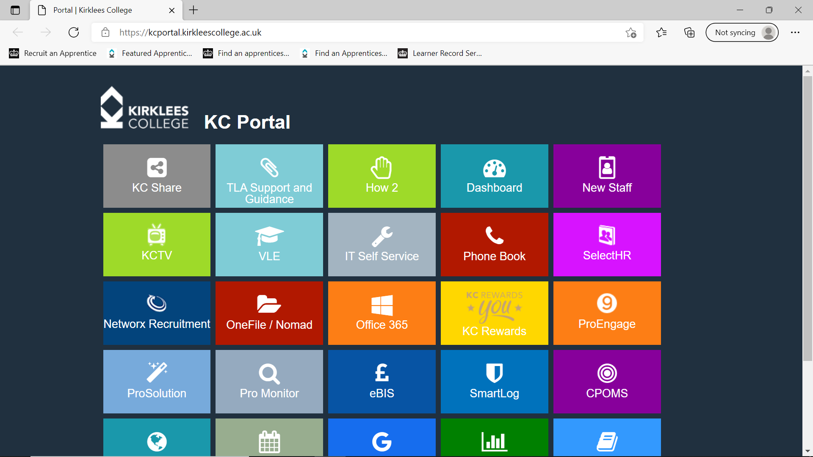

* Then click on New Potential Business
* Fill in details
* Contact Name
* Organisation: (company name)
* Telephone
* Email address
* Put in the box if (Levy or non-levy payer) if business has more than 50 employer they will be a Levy payer.
* Where did you hear about us? Click on list and choose
* Address
* Main business activity etc Hairdressing
* KC Staff to follow up is your name
* Postcode
* Potential business area: Choose which area it is

Then click SUMIT – and DONE!