**DAS Training**

* Have to have a PAYE Scheme/number
* [How to register and use the apprenticeship service as an employer - GOV.UK (www.gov.uk)](https://www.gov.uk/guidance/manage-apprenticeship-funds)
* Click on – REGISTER AS AN EMPLOYER – See below

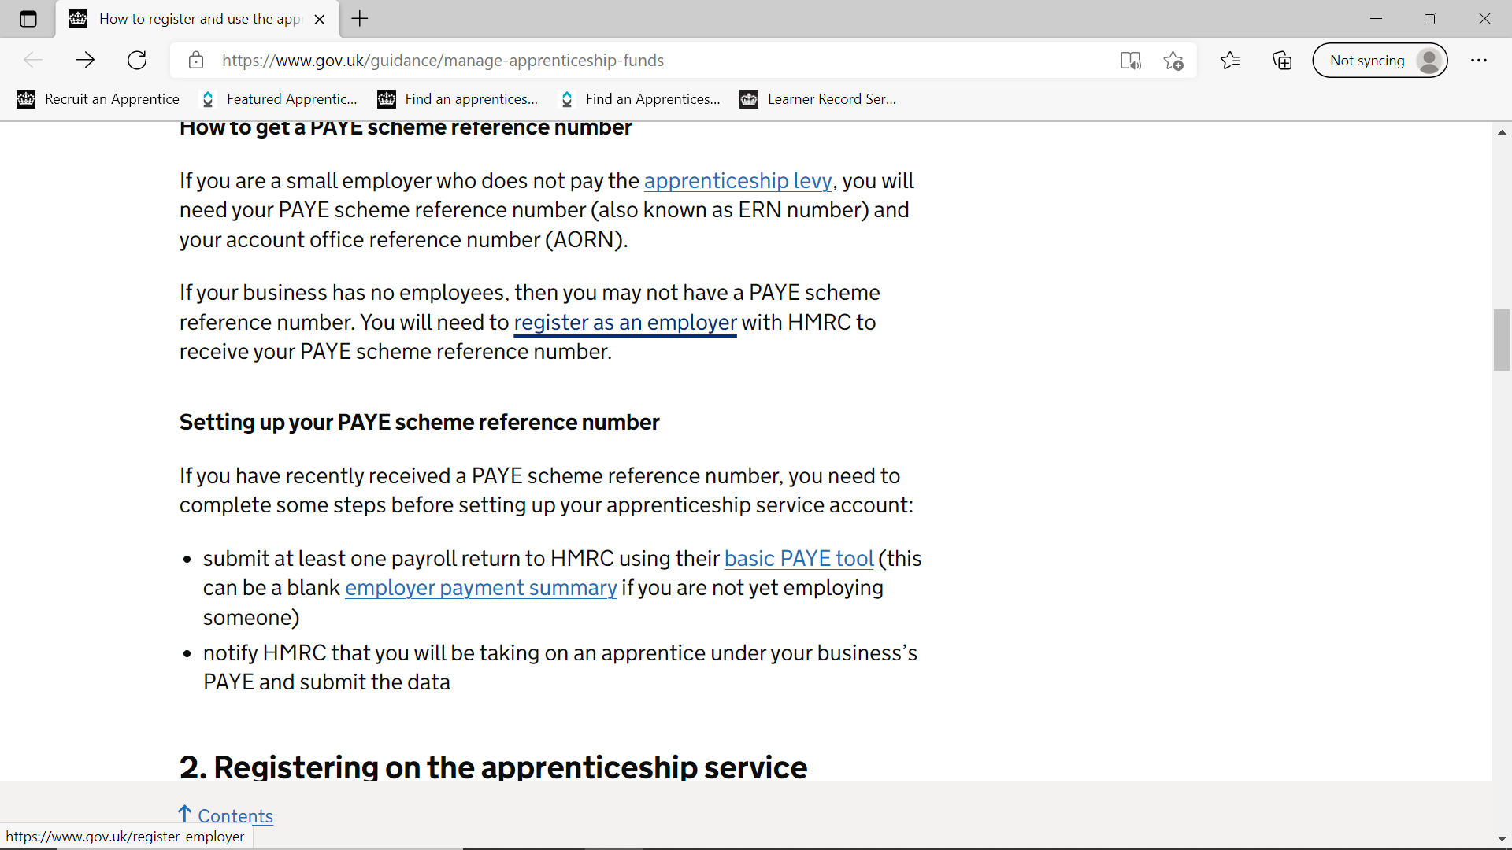

* Can take between 5 – 7 days to register – once have number continue
* Click on section 2. – Registering on the apprenticeship service -

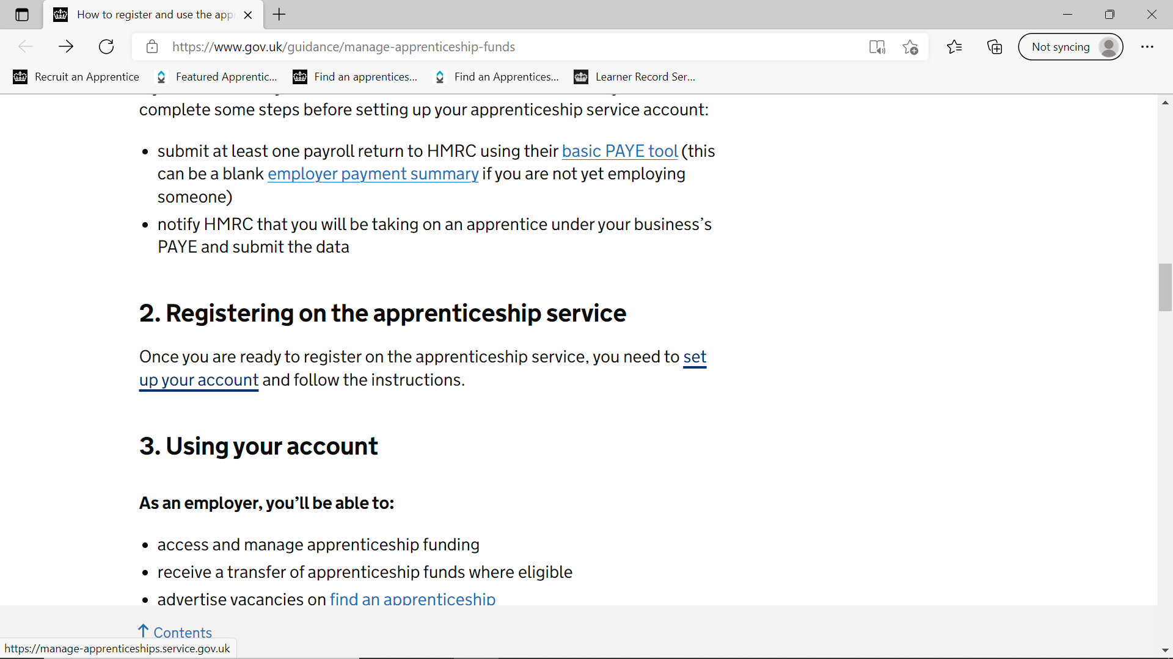

* Employer has to do the rest –

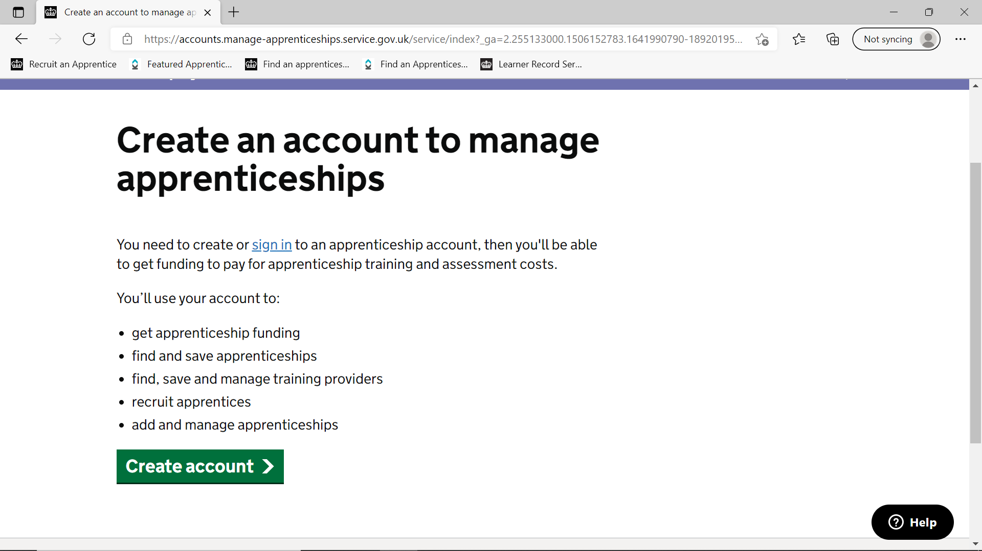

* Once created an account
* Need to add in training provider details: UKPRN NUMBER: 10003189 - Kirklees College
* Can also give permission for College to fill rest of application in (if pathways get put in wrong will have to start again)
* Need to add student details Name and DOB – Company name if different to account in comments box that will appear
* Has to be applied for within 3 months of college course starting